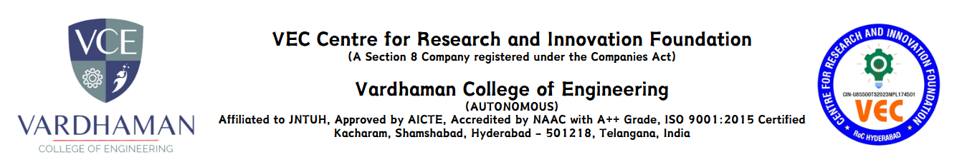
Business Idea Submission Format
Name of the Student : K. Kavya sri
Roll Number : 24885A0543
Branch : CSE
Year : 2nd year
Idea Theme : Tale App: A Social Media Platform for Interactive Storytelling and Multimedia Engagement
Title of the Proposed Idea/Innovation : Tale app
Problem Statement (Not exceeding 1000 words)
• Lack of interactive platforms that merge storytelling and social media features.
• Difficulty in discovering creative content and engaging with it effectively.
• Limited options for multimedia integration in storytelling.

Concept and Objective (Not exceeding 1000 words)
1. Encourage Creativity: Provide a space where users can create and share stories.
2. Interactive Engagement: Enable user interaction through likes, comments, and shares.
3. Multimedia Integration: Allow users to add audio, video, and images to stories.
4. Community Building: Connect users through following, messaging, and collaborative content creation.
5. Kid-Friendly Content: Introduce rhymes and games for young learners.

Newness/Uniqueness of the Innovation (Not exceeding 1000 words)

1. Combining Social Media and Storytelling
Tale App offers an immersive and interactive experience by fusing social networking features with digital storytelling in a novel way. Tale App combines various forms of creative expression, allowing users to create, share, and engage with multimedia-driven stories, in contrast to traditional social media platforms that concentrate on text, images, or videos separately
2. AI-Powered Recommendations and Personalization
Tale App uses artificial intelligence to offer tailored content recommendations based on user preferences, in contrast to other storytelling platforms. Every user will have an interesting and personalized experience thanks to the AI-driven system's recommendations for stories, memes, and multimedia content based on personal interests.
3. Capabilities for Multimedia Storytelling
The Tale App makes storytelling more dynamic and captivating by allowing users to add audio, video, and images to their stories. Narration is possible for users.

Market Potential of Idea/Innovation (Not exceeding 1000 words)
1. Growing Interest in Interactive Storytelling Systems
Platforms for interactive storytelling are becoming increasingly popular as the consumption of digital content rises. By offering a special fusion of social media, multimedia storytelling, and AI-powered content recommendations, Tale App capitalizes on this expanding market. Given the anticipated significant growth in the global digital content market, Tale App has a great chance to gain a sizable user base.
2. Growing Social Networking & Digital Media Sector
With billions of users worldwide, social media and content-sharing platforms have experienced exponential growth. The Tale App's ability to combine social interaction and storytelling is in line with users' desires for interesting and original content. Tale App positions itself as a trailblazing player in this market by incorporating features like gamification, AI-driven recommendations, and memes.
3. Scalability & Global Reach
With chances to grow internationally in a variety of markets, Tale App has enormous scalability potential. The app can serve a variety of users, including casual readers, content producers, students, educators, and digital natives, thanks to its multilingual content and AI-driven localization.
Potential areas of application in industry/market (Not exceeding 1000 words)
In Social Media and Digital Content Sector
By fusing social networking, multimedia, and interactive storytelling, the Tale App is poised to completely transform the digital content market. Engaging content is key for social media platforms, and Tale App's integration of AI-driven storytelling, memes, and video-based storytelling allows users to express themselves in new and imaginative ways. Digital marketers, influencers, and content producers can use the app to expand their audience and improve audience engagement.
Tale App can be used by brands for digital campaigns and brand storytelling. Businesses can produce targeted ads that blend in naturally with the user experience by using personalized AI-driven recommendations. With its immersive stories and social engagement features, Tale App gives businesses an alternate means of connecting with customers as the consumption of digital content keeps growing.
Business Model Canvas
KEY PARTNERS
Content creators, influencers, AI tech firms, publishers, social media platforms, advertisers

CUSTOMER SEGMENT
Writers, digital marketers, students, educators, social media users, businesses, gamers
VALUE PROPOSITION
- AI-powered storytelling 🧠
- Interactive, multimedia-based content 🎥
- Social collaboration & gamification 🎮
- Monetization for creators 💰
- Personalized storytelling 📖

KEY ACTIVITIES
Content curation and AI development 🤖
Partnerships, marketing, and community development 📢
Strategies for monetization 💵

Cloud management and platform security 🔒

CUSTOMER RELATIONSHIPS
Customized AI suggestions 🔍
Participation of the community (challenges & partnerships) 🌍
Premium membership plans and creator incentives 🏆
KEY RESOURCES
ML and AI technology 🔬
Cloud-based infrastructure ☁️
Professional developers 👨‍💻
The marketing team and content creators 🎨
COST
AI and technological advancement ♙️
Cloud security and infrastructure 💾
Influencer partnerships and marketing 📣
REVENUE STREAMS
In-app purchases and subscriptions 💳
Sponsored content and advertisements 📢
Brand partnerships and content licensing 🏢

